**Interview prospective programming questions**

# 1. Write a program to find factorial of the given number. ?

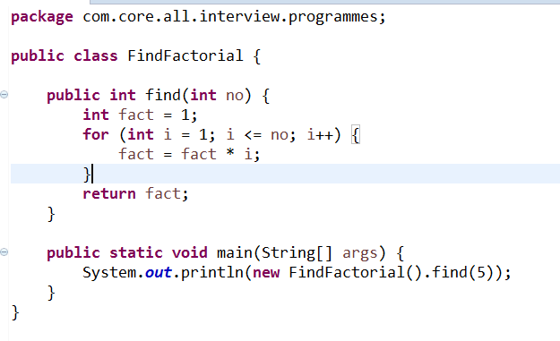2. Write a program to check whether the given number is even or odd.

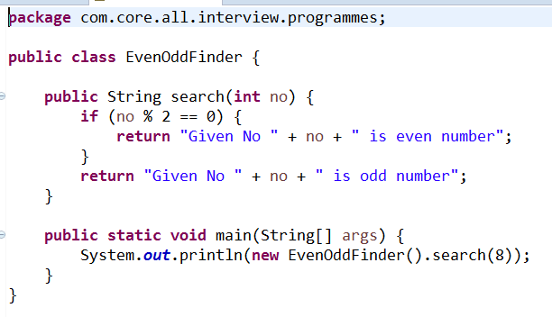

3. Write a program to swap two numbers using a temporary variable.

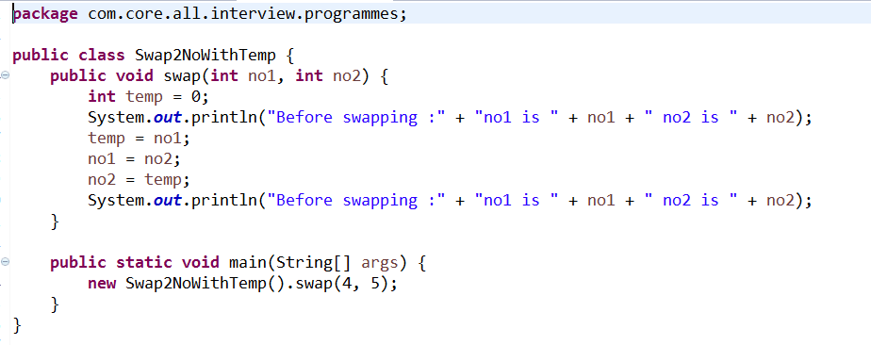4. Write a program to swap two numbers without using a temporary variable.

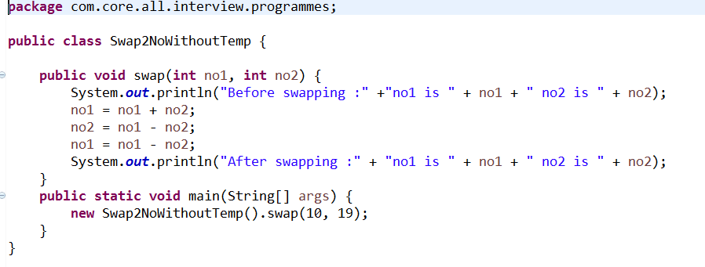

5. Write a program to swap two numbers using bitwise operators.

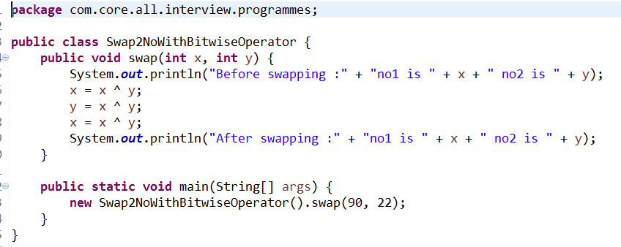

6. Write a program to find the greatest of three numbers.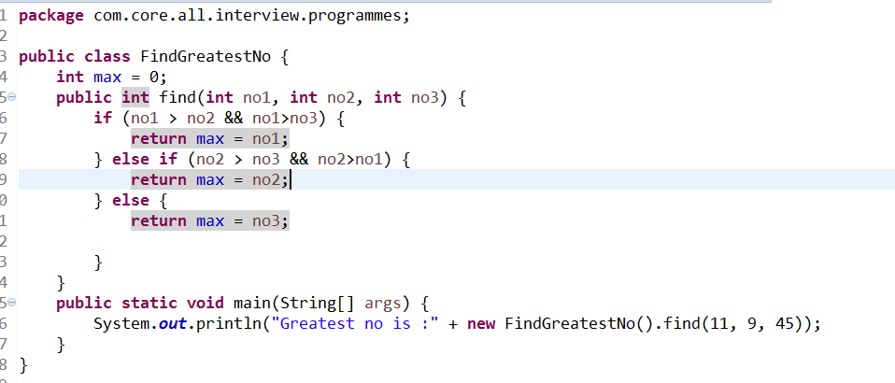7. Write a program to find the greatest among ten numbers.  
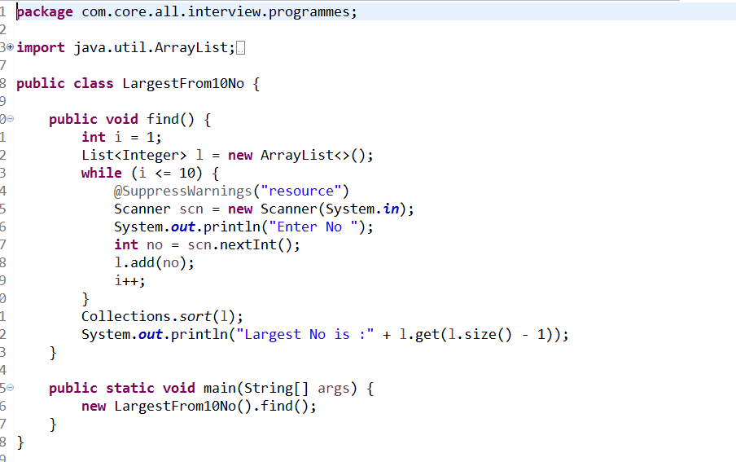

# 8. Write a program to check whether the given number is a prime.

# 9. Write a program to check whether the given number is a palindrome c number.

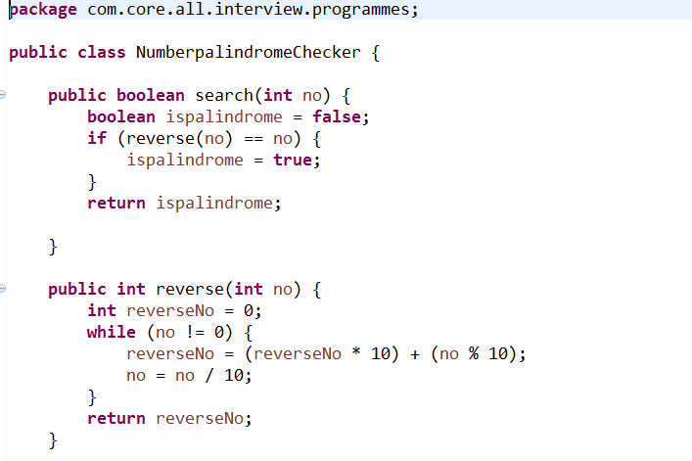

10. Write a program to check whether the given string is a palindrome.

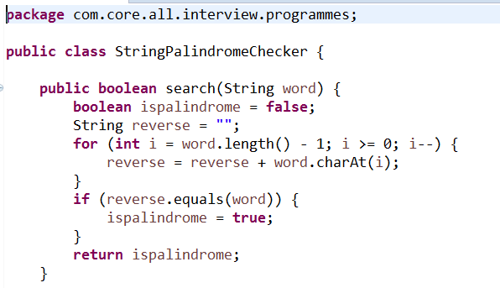

# 11. Write a program to generate the Fibonacci series.

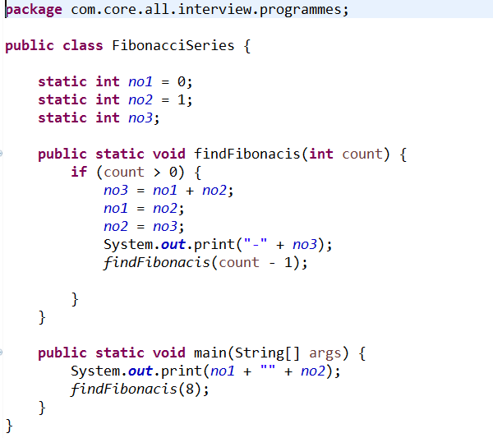

# 12. Write a program to print "Hello World" without using semicolon anywhere in the code.

# 

# 13. Write a program to print a semicolon without using a semicolon anywhere in the code.

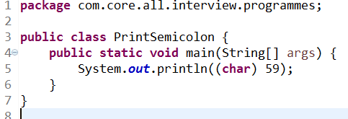

# 14. Write a program to delete a specified line from a text file.

# 

# 15. Write a program to find the number of lines in a text file.

# 16. Write a program to display the multiplication table of a given number.

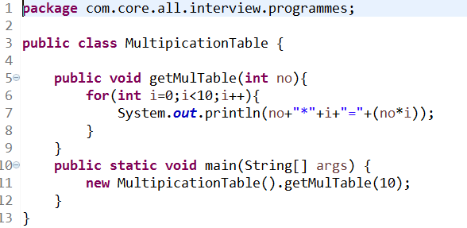

# 17. WAP to find out the longest word in a string.

# 18. WAP to print the triangle of letters in increasing order of lines..

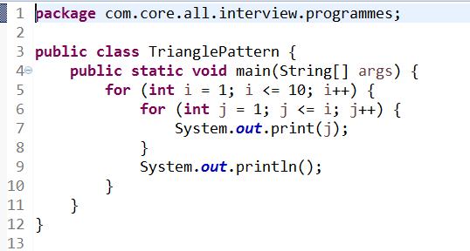

# 19. WAP to print 'xay' In place of every 'a 'in a string

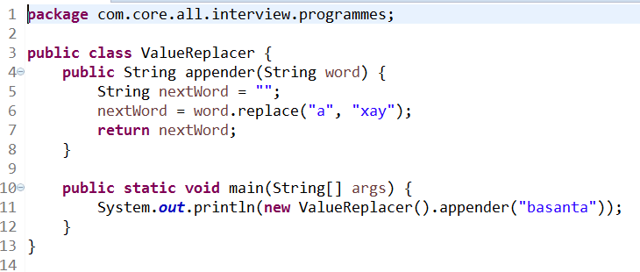

# 20. Count the Total Number of 7 coming between 1 to 100.

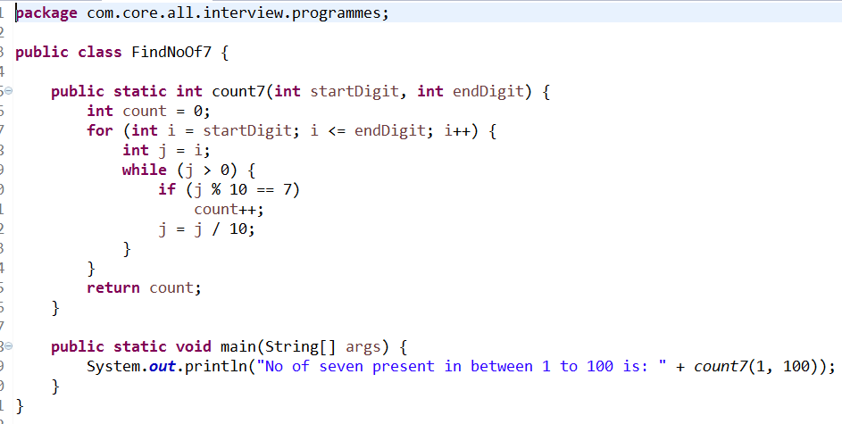

# 21. WAP to find out if a given number is a power series of 2 or not?



 